JOB DESCRIPTION

Official Job Title: | Joint UN Programme Monitoring and Evaluation Analyst
Duty Station: | Lesotho, Maseru
Grade (Classified) | NOB Fixed Term
Post Number:
Post Type: | Rotational Non-Rotational
Classification Authority: |  | Closing Date for applications: 15 June, 2018

1. Organizational Location

The Programme and M&E Analyst of the Swedish funded Joint United Nations Programme on SRHR/HIV and GBV Integration is located in the UNFPA Lesotho based in Maseru, Lesotho. S/He reports to the Programme Coordinator based at UNFPA Lesotho and falls under the overall leadership of UNFPA Representative. The Programme and M&E Analyst will work closely with select programme staff and other key technical, programme and operational staff for the effective implementation of the Programme and Monitoring and Evaluation of the Joint Programme and UNFPA’s efforts on SRHR/HIV. S/He is overall responsible for the monitoring and evaluation of the Joint UN Regional Programme and will work in close collaboration with country focal persons from UNAIDS, UNICEF and WHO and the M&E Focal Persons responsible for the Joint UN Programme to ensure that the Joint United Nations Programme on SRHR/HIV and GBV is effectively monitored and evaluated. S/he will support the strengthening of the monitoring and reporting of UNFPA’s CO efforts including HIV prevention. She/he is responsible for providing policy, programme and operational management guidance to the UN partners, programme staff in an integrated and coordinated manner to ensure the successful monitoring and evaluation of the programme. S/He will work together with the Programme Coordinator to ensure the proper coordination, management and implementation of the Joint UN programme.

2. Job Purpose

The Programme and M&E Analyst will oversee the monitoring and evaluation of the Joint UN Regional Programme on SRHR/HIV and GBV Integration and work closely with the Regional Interagency Work Group and agency assigned focal persons to coordinate the monitoring, evaluation and reporting of the Joint UN Programme and support strategic information related activities relating to the Joint UN Programme and UNFPA’s CO efforts including HIV prevention. S/He is responsible for providing monitoring and evaluation guidance to the participating UN partners, and programme staff in an integrated and coordinated manner to ensure that the results of the Joint Programme are effectively monitored and reported to show impact.
The Programme and M&E Analyst will ensure regular communication with the participating agency focal persons, and their M&E focal persons to ensure that systems are put in place to allow for the routine reporting of activities as required by the funder. All monitoring, evaluation and reporting related commitments will be the responsibility of the Programme and M&E Programme Analyst. S/He will provide strategic advice and ensure appropriate coordination with the various partners on the monitoring and evaluation of the programme. The Programme and M&E Programme Analyst will work with the Programme Coordinator to prepare a consolidated country report, provide reports to the UNFPA Country Representatives, participating UN representatives and to UNFPA ESARO, national steering committee, the regional programme steering committee and funders of the programme.

3. Major Activities/Expected Results

The Programme and M&E Analyst is responsible for the monitoring, evaluation and reporting of the Joint UN Programme on SRHR/HIV and GBV Integration, related Strategic Information Activities and provides programmatic support as required.

- Manage and provide guidance and oversight for overall monitoring and evaluation, strategic information and reporting at country and regional levels
- Manage and coordinate all M&E and Strategic Information activities, including timely and quality reporting, knowledge generation and management;
- Manage monitoring, reporting and contribute to the evaluation of the programme;
A. Coordination and technical support of monitoring and evaluation:
- Coordinate the M&E efforts of the four UN agencies and CO activities to track the results of the implementation of the Joint UN Regional Programme at regional and country level and the work of UNFPA on HIV prevention based upon an agreed upon results framework.
- Ensures that data is provided and collected against the agreed upon indicators using the defined reporting tools and ensures that the SRHR/HIV and SGBV programme results and those relating to UBRAF are accurately captured, measured and reported.
- Provides technical support to the partner UN agencies to ensure that the necessary M&E systems are established to capture and report on progress in relation to the project, and UNFPA activities on HIV prevention and that reports are submitted timeously and to monitor data quality.
- Manages the collation of baseline data in relation to the M&E Framework and ensures that agency and country reports are submitted by the participating UN agencies in good time.
- Respond to technical requests from UN and national partners to strengthen their M&E systems and identify adaptations as may be needed.
- Works with the Regional Programme & M&E Manager and the Interagency Working Group to design the mid-term and end of project evaluation.
- Coordinates and develops programmatic reports for UNFPA ESARO and the Regional Programme Steering Committee on progress made at regional and country level.

B. Strategic Information
- Coordinate the efforts of the UN partners to strengthen their national health management information systems so that they are able to monitor the provision of integrated SRHR/HIV and SGBV services including the CO activities.
- Work with UNAIDS and the UNFPA Strategic Information Units to integrate key indicators relating to SRHR and GBV into the country information hub and country situation rooms.
- Work with the four UN partners to produce reports and updates that show country progress in meeting national targets.
- Document lessons learnt, share knowledge and disseminate good practices, on the monitoring and evaluation of SRHR/HIV and SGBV in the ESA region;
- Support the country team to prepare manuscripts and abstracts for submission to international, regional and national journals, conferences and other fora to share lessons learnt.
- Facilitate, act as resource person, and join if required any external supervision and evaluation missions.

C. Development of work plans and reporting
  - Review and provide input in the preparation of annual Country Office work plans from an M&E perspective and ensure that the monitoring and evaluation indicators are aligned to the M&E Framework.
- Coordinate the development of a semi-annual, annual and other project reports as may be required that shows progress in relation to the work plan and the results framework at country and regional level, with a focus on impact.
- Develop and prepares an annual programme results reports for presentation to the Regional Programme Steering Committee that captures both the direct and catalytic actions of the programme.
- Provide an analysis of the data, its implications for programme implementation and initiate operational research activities that will inform and strengthen programme implementation.
- Oversee the design of the mid-term and end-of-project evaluation in collaboration with the four partner agencies and the ten countries and its implications for programme management.

4. Work Relations

External partners include the programme's main donor (Sweden), UN agencies in particular the regional teams of UNAIDS, UNICEF and WHO, donor and the participating governments of the countries concerned, NGOs, Academia, Research Institutions, professional associations, and international experts, in developing a network of technical experts and institutions for technical and programme support.

Internal partners include UNFPA programme, operational and technical staff, resource mobilisation and partnership Adviser, Communication Team; programme and technical staff involved in the programme; relevant UNFPA headquarters units. In all activities, s/he supports the Programme Coordinator to foster collaboration within the country Office, particularly amongst the team involved in the implementation of the programme.

5. Job Requirements

- Education: Master Degree in Statistics, Demography, Social Sciences, or Public Health; Postgraduate training in monitoring and evaluation and knowledge in health sector is an added advantage.

Knowledge and Experience:

- At least 5 – 10 years’ experience in monitoring and evaluation, results based programme development and management.
- Experience in developing indicators, data collection tools, M&E plans and results frameworks in HIV and SRH.
- Knowledge of National Health Information Systems desirable.
- Ability to write clear and comprehensive reports.
- Experience in capacity building on M&E.
- Excellent computer skills especially Access, Excel, SPSS and GIS.
- Fluent in English with excellent writing, analysis and communication skills Excellent Writing skills in English. Knowledge of other UN language is an asset.

Required Competencies:

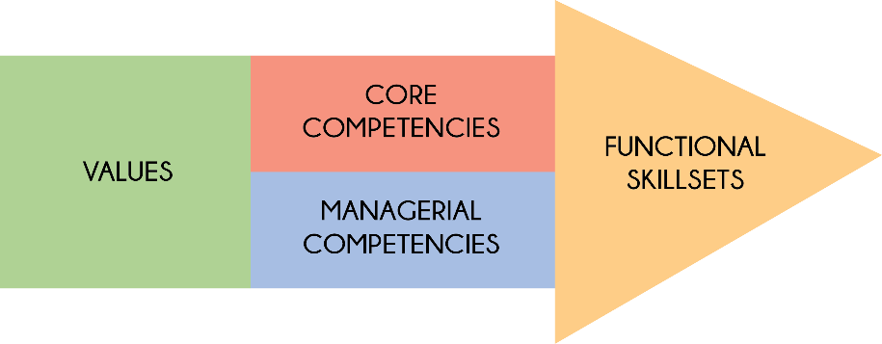

Values:
- Exemplifying integrity
- Demonstrating commitment to UNFPA and the UN system
- Embracing cultural diversity
- Embracing change

Core Competencies:
- Achieving results
- Being accountable
- Developing and applying professional expertise/ business acumen
- Thinking analytically and strategically
- Working in teams/ managing ourselves and our relationships
- Communicating for impact

Managerial Competencies:
- Providing strategic focus
- Engaging internal/ external partners and stakeholders
- Leading, developing and empowering people/ creating a culture of performance
- Making decisions and exercising judgment

Functional Skill Set:
- Advocacy/ Advancing a policy-oriented agenda
- Leveraging the resources of national governments and partners/ building strategic alliances and partnerships
- Delivering results-based programme
- Internal and external communication and advocacy for results mobilization

Languages:

Fluency in English. Depending on the duty station, a working knowledge of another UN language such as French, Spanish, Arabic, Chinese or Russian may be required.

6. Signatures/Certification:

Incumbent’s Name & Signature  (If Applicable) | <Enter Incumbent's Name Here>  <Date>
Immediate Supervisor’s Name & Signature | <Enter Supervisor's Name Here>  <Date>
Division Director’s Name & Signature | <Enter Division Director's Name Here>  <Date>

Applications should be emailed to; lesotho.office@unfpa.org

